**LIT TRAINING**

**Batch Name - SAP ABAP - 25 DAY 14 ASSIGNMENT EMPLOYEE ID – 46247688**

**NAME – DEBPRATIM CHAKRABORTY**

CDS-Assignment 1 –

Create a Simple CDS view with Date Functions in ABAP CDS Views

@AbapCatalog.sqlViewName: 'ZSQL_14'

@AbapCatalog.compiler.compareFilter: true

@AbapCatalog.preserveKey: true

@AccessControl.authorizationCheck: #NOT_REQUIRED

@EndUserText.label: 'DAY14cds'

**define** **view** zDAY14CDS **as** **select** **from** vbak **{**

vbeln **as** Sales_Document**,**

auart **as** Sales_Document_Type**,**

audat **as** Document_Date**,**

vdatu **as** Requested_delivery_date**,**

DATS_DAYS_BETWEEN**(**audat**,** vdatu**)** **as** no_of_days**,**

DATS_ADD_DAYS**(**vdatu**,** 10**,** 'NULL'**)** **as** shipping_date**,**

DATS_ADD_MONTHS**(**vdatu**,** 2**,** 'NULL'**)** **as** billing_date

**}**

**OUTPUT:**

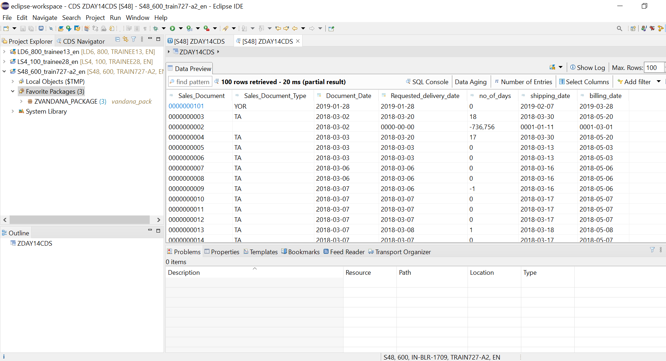

 CDS-Assignment 2 –

Create a Simple CDS view with String Functions in ABAP CDS Views

@AbapCatalog.sqlViewName: 'ZSQL_DAY14Q2'

@AbapCatalog.compiler.compareFilter: true

@AbapCatalog.preserveKey: true

@AccessControl.authorizationCheck: #NOT_REQUIRED

@EndUserText.label: 'DAY14Q2'

**define** **view** zDAY14_q2 **as** **select** **from** kna1 **{**

      kunnr **as** Customer_Number**,**

      land1 **as** Country_Key**,**

      concat**(**kna1**.**name1 **,** kna1**.**name2**)** **as** concat_fields**,**

      concat_with_space**(**stras**,**ort01**,**2**)** **as** con_space **,**

      left**(**name1**,**2**)** **as** no_of_char_left**,**

      right**(**kna1**.**name1**,**3**)** **as** no_of_char_right**,**

      length**(**telf1**)** **as** no_of_char**,**

      substring**(**name1**,**2**,**4**)** **as** char_str**,**

      ltrim**(**kunnr**,** '0'**)** **as** rem_zeros**,**

      rtrim**(**telf1**,**'4'**)** **as** rem_last_char

**}**

**OUTPUT:**

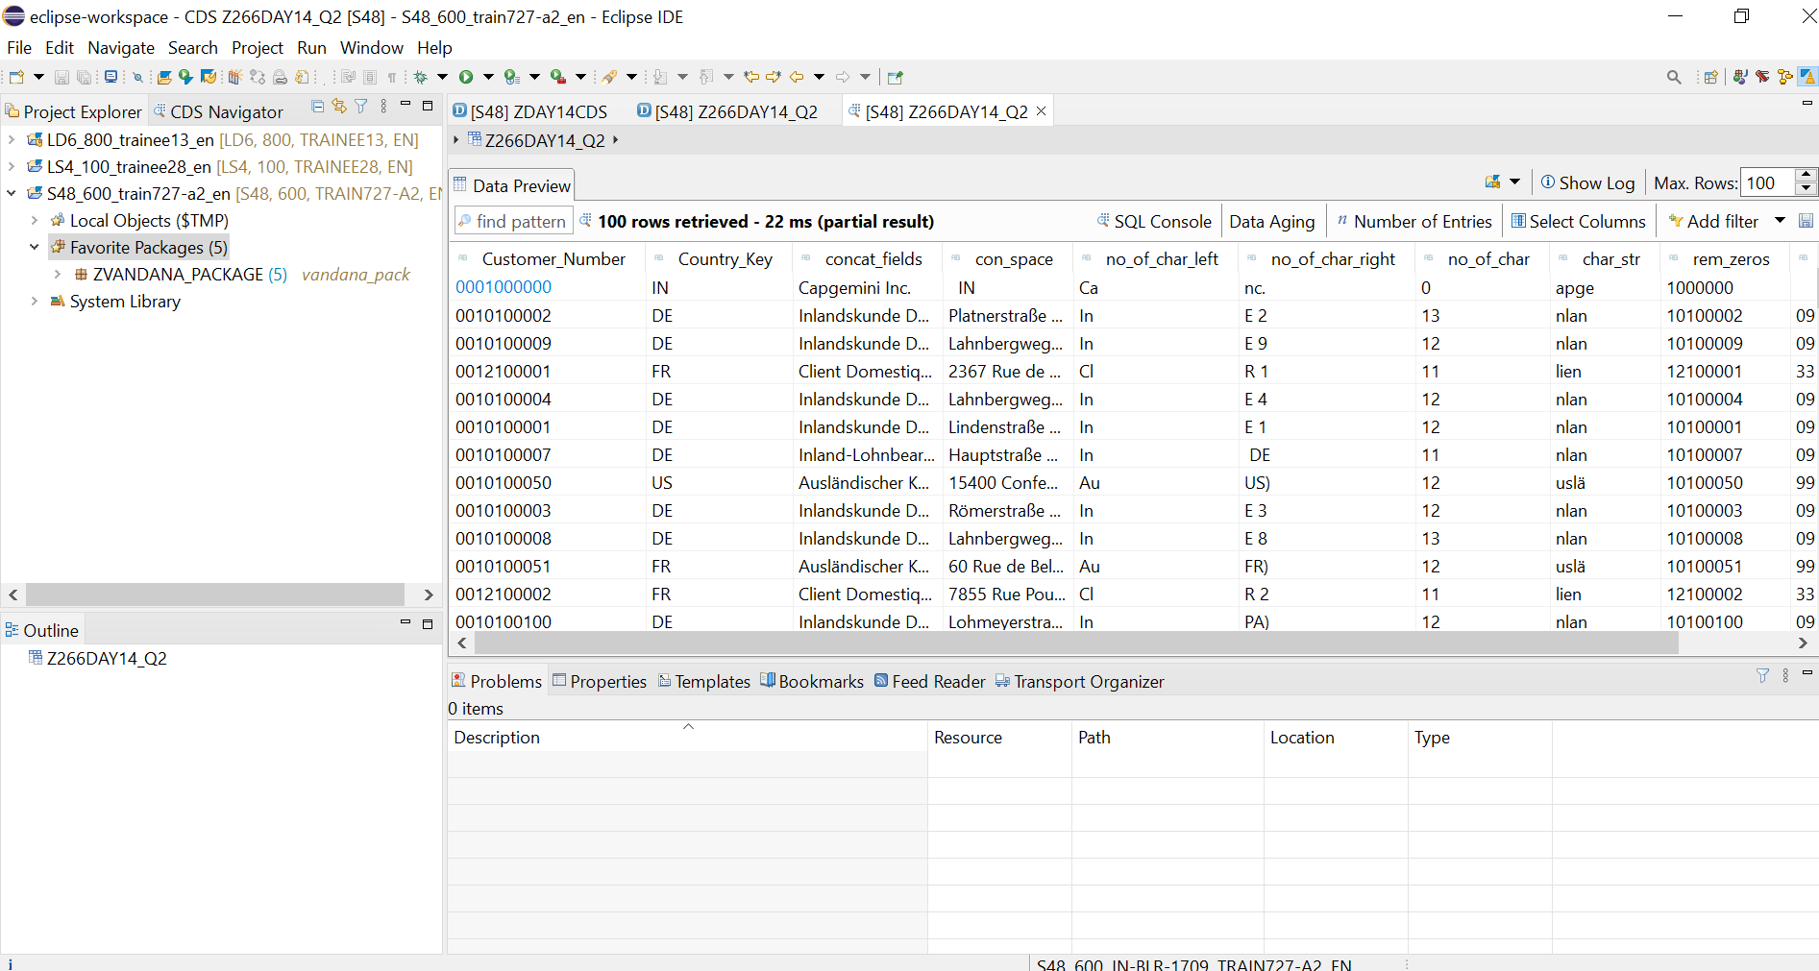

CDS-Assignment 3 – Create a Simple CDS view with Parameters

**Scenario** –

* Create a CDS view with GL currency (PSWSL) as parameter and get the entries form BSEG

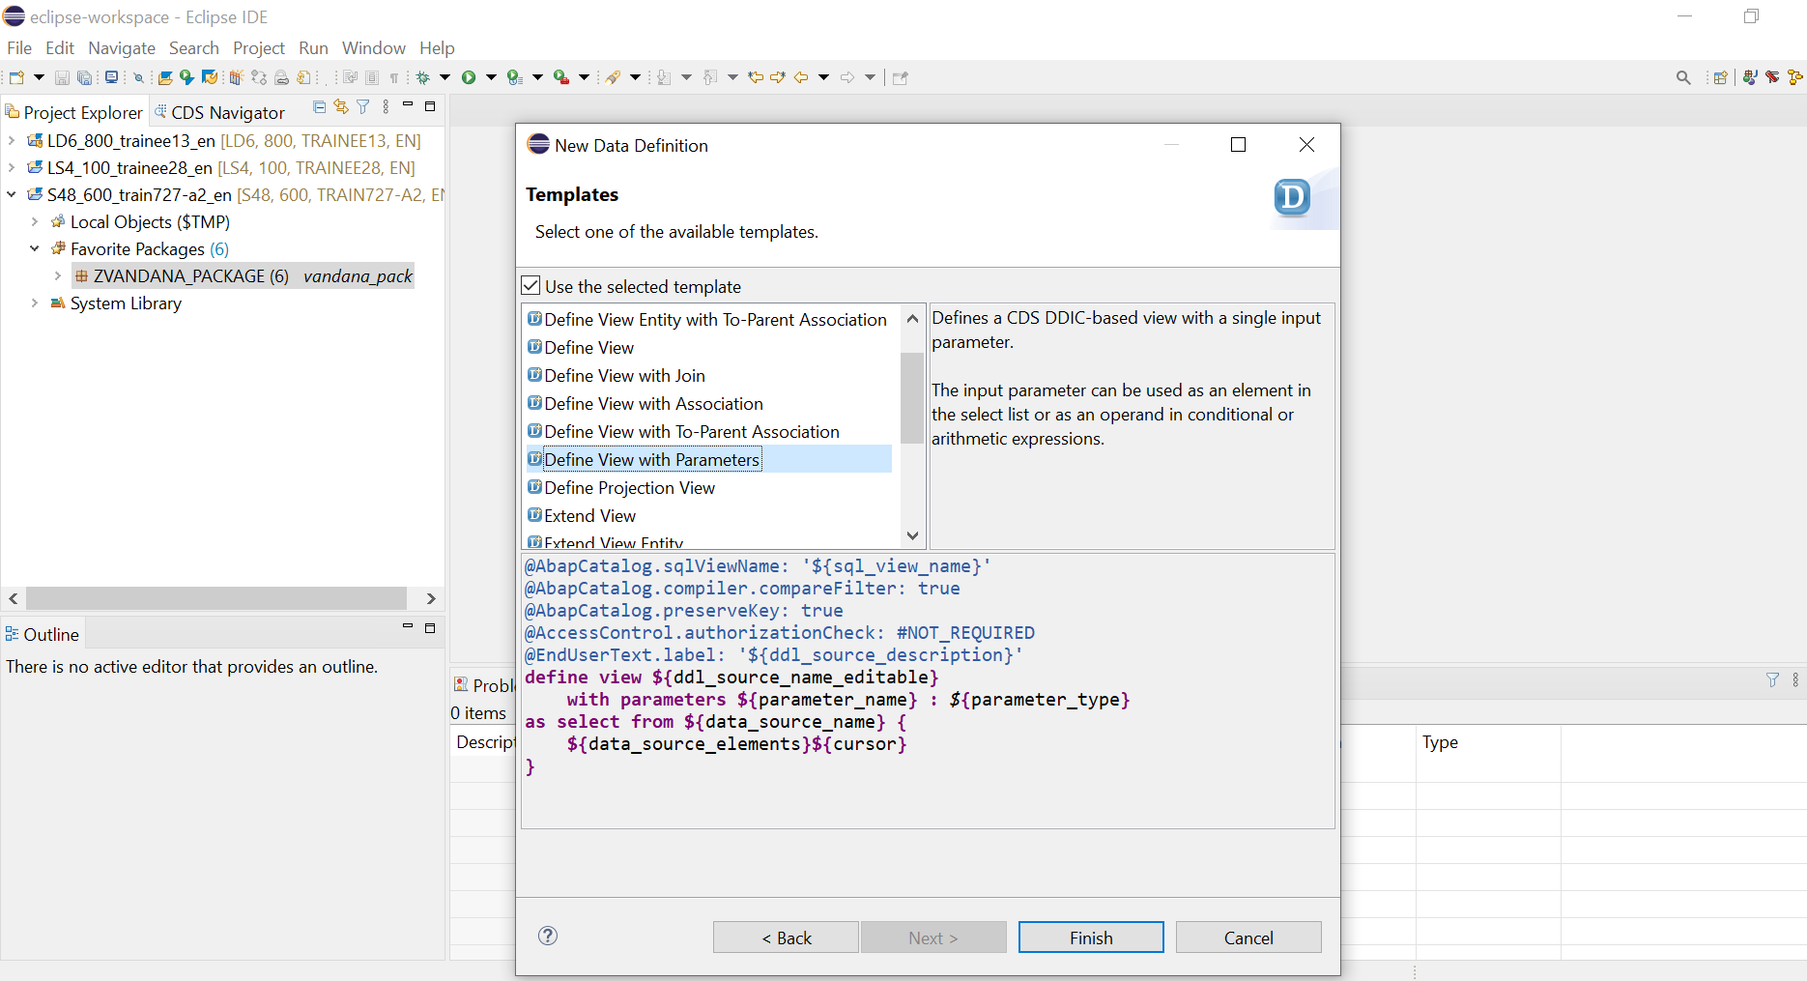

 @AbapCatalog.sqlViewName: 'Z_CDSPAR'

@AbapCatalog.compiler.compareFilter: true

@AbapCatalog.preserveKey: true

@AccessControl.authorizationCheck: #NOT_REQUIRED

@EndUserText.label: 'CDS WITH PARAMETERS'

**define** **view** z_d14q3

**with** **parameters** in_curr **:** *abap***.***cuky***(**5**)**

**as** **select** **from** bseg**{**

    bukrs**,**

    belnr**,**

    gjahr**,**

    buzei**,**

    augdt**,**

    pswsl

**}where** pswsl **=** **$parameters.**in_curr

**output:**

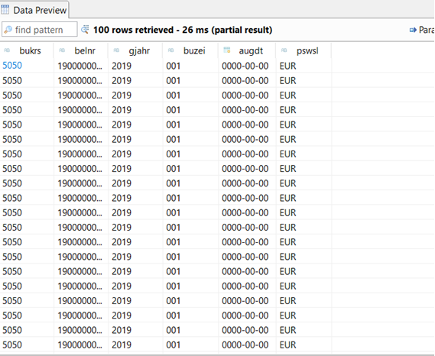

AMDP-Assignment 1 – Procedures - create a basic procedure to fetch data with scalar variable

**Scenario** –

Print Sales Order number, Material Number, Quantity from VBAP table using scaler variable

**Tables involved** – VBAP

**AMDP CLASS:**

class z_d14_amdp1definition

  public

  final

  create public .

  public section.

  TYPES:BEGIN OF TY_vbap,

      vbeln   TYPE vbeln_va,

      matnr   TYPE matnr,

      zmeng   TYPE  dzmeng,

        END OF TY_vbap.

    TYPES: it_vbap TYPE STANDARD TABLE OF ty_vbap WITH EMPTY KEY.

   INTERFACES IF_AMDP_MARKER_HDB.

   class-METHODs get_details

    IMPORTING

      VALUE(iv_vbeln) TYPE vbeln

    EXPORTING

      VALUE(et_order) TYPE it_vbap.

  protected section.

  private section.

ENDCLASS.

CLASS z_d14_amdp1IMPLEMENTATION.

METHOD get_details BY DATABASE PROCEDURE

                  FOR HDB

                  LANGUAGE SQLSCRIPT

                  USING vbap.

et_order = SELECT vbeln,

                   matnr,

                   zmeng

                   From vbap where vbeln = iv_vbeln;

    endmethod.

ENDCLASS.



**REPORT:**

*&---------------------------------------------------------------------*

*& Report z_d14_amdp1

*&---------------------------------------------------------------------*

* Description:                                                        *

*                                                                      *

* Author:                                                             *

*                                                                      *

* Create date:                                                       *

*                                                                      *

*&---------------------------------------------------------------------*

* Modification log:                                                    *

* -------------------------------------------------------------------- *

* Date        User name      ID       Change Request   Case ref.       *

*             Description                                              *

*&---------------------------------------------------------------------*

REPORT z_d14_amdp1.

PARAMETERS : p_vbeln type vbeln.

zz64_d14_amdp1=>GET_DETAILS(

  exporting

    IV_VBELN = p_vbeln

  importing

    ET_ORDER = data(ta_vbap)

).

cl_demo_output=>display_data(

  EXPORTING

    value = ta_vbap

    name  = 'Sales Details'

).

**OUTPUT:**

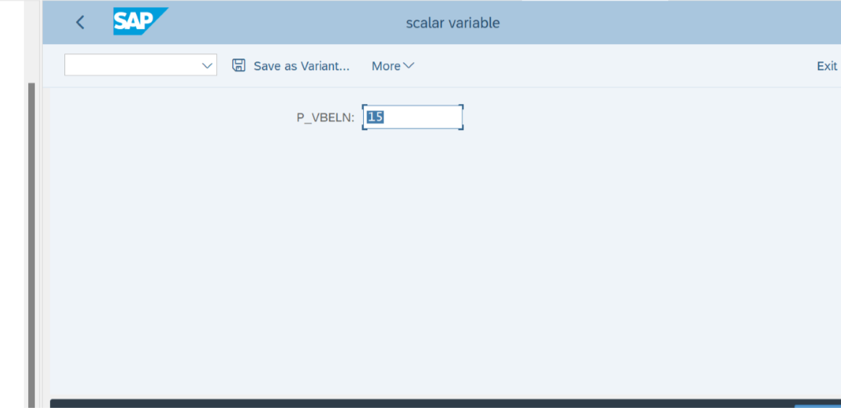

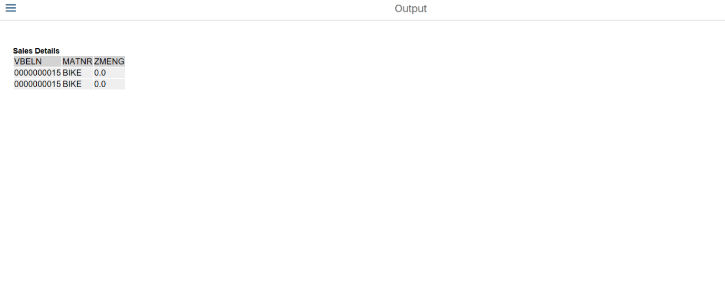AMDP-Assignment 2 – Procedures - create a basic procedure with Table

**Scenario** –

* Select VBELN, VKORG, MATNR, MENGE from VBAK and VBAP and display the data using table based on material (MATNR).
* MATNR will be input field
* Do inner join

**Tables involved** – VBAK, VBAP

**AMDP CLASS:**

class z_d14_amdp2definition

  public

  final

  create public.

  public section.

   TYPES: BEGIN OF TY_SALES,

        VBELN TYPE VBELN_VA,

        VKORG TYPE VKORG,

        MATNR TYPE MATNR,

        MATKL TYPE MATKL,

        END OF TY_SALES.

    TYPES IT_SALES TYPE TABLE OF TY_SALES.

    INTERFACES IF_AMDP_MARKER_HDB.

   CLASS-METHODS

        GET_SALES

            IMPORTING VALUE(IM_MATNR) TYPE MATNR

            EXPORTING VALUE(EX_SALES) TYPE IT_SALES.

  protected section.

  private section.

ENDCLASS.

CLASS z_d14_amdp2IMPLEMENTATION.

 METHOD GET_SALES BY DATABASE PROCEDURE

                     FOR HDB

                     LANGUAGE SQLSCRIPT

                     USING VBAK VBAP.

    EX_SALES = SELECT V1.VBELN,

                      V1.VKORG,

                      V2.MATNR,

                      V2.MATKL

                   FROM VBAK AS V1 INNER JOIN VBAP AS V2

                   ON V1.VBELN = V2.VBELN

                   WHERE MATNR = IM_MATNR;

endmethod.

ENDCLASS.

REPORT:

*&---------------------------------------------------------------------*

*& Report z_amdp2_d14

*&---------------------------------------------------------------------*

* Description:                                                       *

*                                                                      *

* Author:                                                            *

*                                                                      *

* Create date:                                                       *

*                                                                      *

*&---------------------------------------------------------------------*

* Modification log:                                                    *

* -------------------------------------------------------------------- *

* Date        User name      ID       Change Request   Case ref.       *

*             Description                                              *

*&---------------------------------------------------------------------*

REPORT z_amdp2_d14 .

Parameters : p_matnr type matnr.

z_d14_amdp2=>GET_SALES(

  exporting

    IM_MATNR = p_matnr

  importing

    EX_SALES = DATA(RS_VBAK)

).

CL_DEMO_OUTPUT=>display_data(

  EXPORTING

    value = RS_VBAK

    name  = 'Sales Order Details using Join'

).

**OUTPUT:**

